
Module Title
Principles of Programming
Assessment Weightage & Type
50% of Coursework & Regular Year
2025

Student Name: NIRVIK K.C.
UWE ID: 25024649
Assignment Submission Date: January 18, 2026

1
25024649
Submission details
Module title and code: UFCFHS-30-1 Principles of Programming Individual Assignment
Assessment type: Individual Assignment – Software Development Portfolio
Assessment title: Application for Car Parts and Accessories Shop
Assessment weighting: 50% of total module mark

Step 1
Imagine a Car Parts and Accessories shop, which requires a software system to keep track of stock items and prices. The shop will sell different kinds of stock items. However, to start with, you have been tasked with designing and implementing a class called StockItem with the following properties.
▪ An instance (object) of the StockItem class represents a particular item which the shop sells, with a string representing fixed stock code, an integer representing variable quantity in stock and a double representing variable price of the stocked item. All these variables should be declared as private variables. The StockItem class also contains a class variable (shared by all instances) of type string representing stock category which you can initialise as 'Car accessories'.
▪ A constructor that creates a Stock Item with the specified quantity, price and the stock code.

2
25024649
▪ All the appropriate ‘setters’ and ‘getters’ methods, including a getStockName() method which returns the string "Unknown Stock Name" and a getStockDescription() method which returns the string "Unknown Stock Description".
▪ An increaseStock() method that increases the stock level by the given amount. If the value is less than 1 or the stock exceeds 100, a suitable error message should be printed.
▪ A sellStock() method that attempts to reduce the stock level by the given amount. If it is less than 1, a suitable error message should be printed. If the amount is otherwise less than or equal to the stock level, then the reduction is successful and true is returned. Else there is no effect, but false is returned.
▪ A getVAT() method that returns the standard percentage VAT rate, e.g., you can use 17.5
▪ Appropriate ‘setters’ method for price (without VAT) and ‘getters’ methods for price with and without VAT ▪ A method named __str__ () that returns a string giving the stock code, the stock name, the description, the quantity in stock, the price before VAT and the price after VAT. It must use the appropriate methods above to obtain the stock name, description, quantity and prices.

3
25024649
Task 1.1 Design and draw the corresponding UML class diagram of the StockItem class.
Answer:
UML Diagram for Step 1:
StockItem

- fuelLevel: float

+ stockCategory: String = "Car accessories” «class variable»
- stockCode : String
- quantity : int
- price: float

- price : float

e

+ __init__(stockCode: String, quantity: int, price: float)
+ getStockCode(): String
+ getQuantity(): int
+ getPrice(): float
+ getStockName(): String
+ getStockDescription() : String
+ getItemType(): String
+ getPriceWithoutVAT(): float
+ getPriceWithVAT(): float
+ getVAT(): float
+increaseStock(amount: int): void
+ sellStock(amount: int): void
+ setPrice(new_price: float): void
+ create_table(): void «classmethod»
+ save_to_db(): void
+ load_from_db(stockCode: String): StockItem «classmethod»
+ plot_chart(): void «classmethod»
+ export_to_csv(filename: String = "export.csv"): void «classmethod»
+ __str__(): String

4
25024649
Note:
stockCategory: default value “Car accessories” (class variable)
stockCode: immutable – cannot be changed after initialization
quantity: modified only by increaseStock() and sellStock() methods
price: must be non-negative, set via setPrice()
increaseStock(): amount constraints – min1, max 100 per operation
sellStock(): amount must be $≤$ current quantity
getStockName(): default “Unknown Stock Name”
getStockDescription(): default “Unknown Stock Description”
getItemType(): default “General Car Accessory”
VAT rate: default value is 17.5%
All instance attributes private (-)

All methods public (+)
Exception: stockCategory is public (+) as it is a class variable shared by all instances.

5
25024649
Task 1.2. (Implementation and testing) Implement the above class and test it. You should create some instances of StockItem class, increase stock, sell some stock and change the price, whilst printing out the items in between. Testing is typically a part of the program development – you should use a test strategy to test your program thoroughly. You may look at your practical exercises, identify suitable test cases for the StockItem class, write and document them in the form of a table along with the UML class design file.
Test Cases | Purposes | Expected result | Outcome
Test Case 1 | Create StockItem object with valid parameters | Object created successfully, saved to database | Pass and no error
Test Case 2 | Test getStockCode() method | Returns ‘W101” | Pass - No errors
Test Case 3 | Test getQuantity() method | Returns 10 | Pass - No errors
Test Case 4 | Test getPriceWithoutVAT() method | Returns 99.99 | Pass - No errors
Test Case 5 | Test getPriceWithVAT() method | Returns 117.49 (with 17.5% VAT) | Pass - No errors

6
25024649
Continue table:
Test Cases | Purposes | Expected result | Outcome
Test Case 6 | Test getStockName() method | Returns "Unknown Stock Name" | Pass - No errors
Test Case 7 | Test getStockDescription() method | Returns "Unknown Stock Description | Pass - No errors
Test Case 8 | Test getItemType() method | Returns "General Car Accessory" | Pass - No errors
Test Case 9 | Test increaseStock() with valid amount (10) | Quantity increases from 10 to 20, success message displayed | Pass - No errors
Test Case 10 | Test increaseStock() with zero (0) | Error message: "Increased item must be greater than or equal to one" | Pass - No errors
Test Case 11 | Test increaseStock() with negative value (-5) | Error message: "Increased item must be greater than or equal to one | Pass - No errors
7

25024649
Continue table:
Test Cases | Purposes | Expected result | Outcome
Test Case 12 | Test increaseStock() exceeding maximum (101) | Error message: "Increased item must be less than or equal to 100" | Pass - No errors
Test Case 13 | Test increaseStock() with invalid string ("ten") | Error message: "Amount must be a whole number (integer)" | Pass - No errors
Test Case 14 | Test sellStock() with valid amount (2) | Quantity decreases to 18, message: "Sold 2 and Remaining: 18" | Pass - No errors
Test Case 15 | Test sellStock() with zero (0) | Error message: "Cannot sell less than 1 item" | Pass - No errors
Test Case 16 | Test sellStock() exceeding stock (1000) | Error message: "Only 12 items in stock - can't sell 1000" | Pass - No errors

8
5024649
Continue table:
Test Cases | Purposes | Expected result | Outcome
Test Case 17 | Test sellStock() triggering low stock alert (≤5) | Alert message: "Restock your items is recommended. Low stock alert!" | Pass - No errors
Test Case 18 | Test sellStock() triggering critical alert (≤2) | Alert message: "Stock items are critically low. Only a few units left!" | Pass - No errors
Test Case 19 | Test sellStock() reaching zero stock | Alert message: "Items are unavailable. Out of stock!" | Pass - No errors
Test Case 20 | Test str() method output | Returns formatted string with all stock information | Pass - No errors

9
25024649
Step 2
The Car Parts and Accessories shop has got plenty of GeoVision Sat Nav navigation system at very competitive prices, which are going to be the first item on sale. You need to design and implement a class NavSys which is a sub-class of StockItem.
▪ You also need to create one new private instance variable of your NavSys class to represent navsys brand.
▪ A parameterised constructor of the NavSys class must call the StockItem’s constructor using super to initialise the super class’s instance variables.
▪ The NavSys class will override the instance methods getStockName() and getStockDescription() with ones that return "Navigation system" and " GeoVision Sat Nav" respectively.
▪ NavSys class will also override the __str__ () method using the concept of super in Python.

Task 2.1 (Revised design). Revise your UML class diagram in Task 1.1, to incorporate the NavSys class and show their relationship using appropriate UML notations.
Answer:
UML Diagram for Step 2:
10
+ stockCategory: String = "Car accessories” «class var»
- stockCode : String
- quantity : int
- price: float

- price : float

StockItem

- fuelLevel: float

+ __init__(stockCode: String, quantity: int, price: float, brand: String)
+ getStockName(): String «override»
+ getStockDescription(): String «override»
+ getItemType(): String «override»
+ __str__(): String «override»

- brand: String

NavSys

- fuelLevel: float

+ __init__(stockCode: String, quantity: int, price: float)
+ getStockCode(): String
+ getQuantity(): int
+ getPrice(): float
+ getStockName(): String
+ getStockDescription() : String
+ getItemType(): String
+ getPriceWithoutVAT(): float
+ getPriceWithVAT(): float
+ getVAT(): float
+increaseStock(amount: int): void
+ sellStock(amount: int): void
+ setPrice(new_price: float): void
+ create_table(): void «classmethod»
+ save_to_db(): void
+ load_from_db(stockCode: String): StockItem «classmethod»
+ plot_chart(): void «classmethod»
+ export_to_csv(filename: String = "export.csv"): void «classmethod»
+ __str__(): String

11
25024649
Notes:
For StockItem class:
stockCategory: default "Car accessories" (class variable, shared by all instances)
stockCode: immutable – cannot be changed after initialization
price: must be non-negative, validated in setPrice()
increaseStock(): amount constraints – min 1, max 100 per operation
sellStock(): amount must be $≤$ current quantity
getStockName(): default “Unknown Stock Name”
getStockDescription(): default "Unknown Stock Description"
getItemType(): default "General Car Accessory"
VAT rate: default “value fixed at 17.5%”

For NavSys Class:
All the attributes and methods are inherited from StockItem
Add new private attributes brand (required, no default value)
Overrides methods: getStockName(), getStockDescription, getItemType(), __str__()
getStockName(): default “Navigation system”
12
25024649
getStockDescription: default “GeoVision Sat Nav”
getItemType(): default “Navigation System”
__str__(): calls super().__str__ and appends the brand information

All instance attributes private (-)
All methods public (+)
Exception: stockCategory is public (+) as it is a class variable shared by all instances.

Clear picture of UML diagram:

Continue to next page.

13
25024649
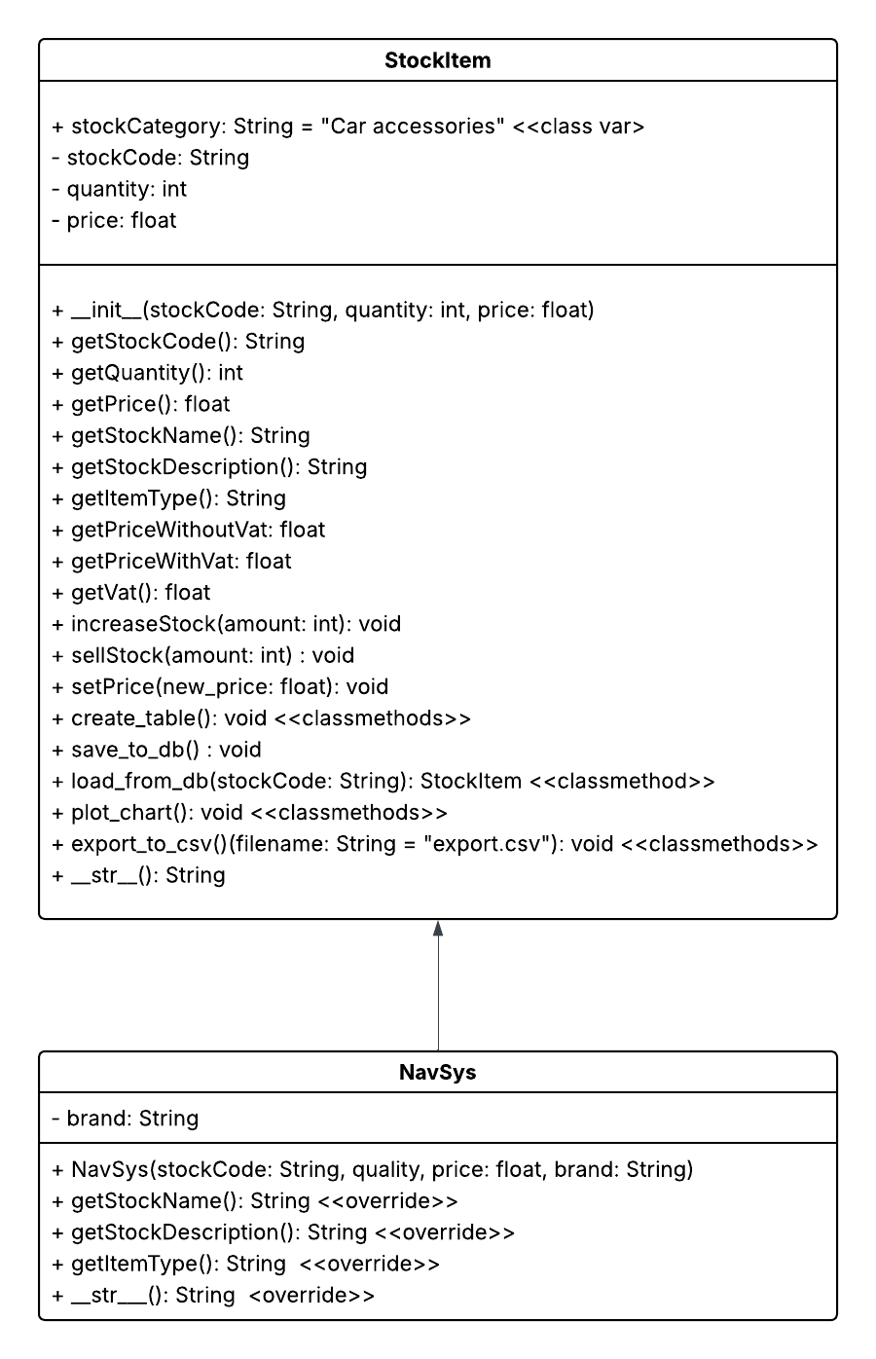
Figure 1 : Image View of UML Diagram for Application for Car Parts and Accessories Shop (Lucidchart)
14
25024649
Task 2.2 (Revised implementation and testing). Implement the NavSys class and test it by creating an instance of NavSys, adding and then selling some navigation system stock and changing the price, whilst printing out the item in between.

Test Cases | Purposes | Expected result | Outcome
Test Case 21 | Create NavSys object with valid parameters including brand | Object created with brand "TomTom" and saved to database | Pass – No Errors
Test Case 22 | Test getStockCode() inherited method | Returns "NS401" | Pass – No Errors
Test Case 23 | Test getQuantity() inherited method | Returns 10 | Pass – No Errors
Test Case 24 | Test getPrice() inherited method | Returns 99.99 | Pass – No Errors
Test Case 25 | Test getPriceWithoutVAT() inherited method | Returns 99.99 | Pass – No Errors
Test Case 26 | Test getPriceWithVAT() inherited method | Returns 117.49 (with 17.5% VAT) | Pass – No Errors

15
25024649
Continue table:
Test Cases | Purposes | Expected result | Outcome
Test Case 27 | Test getStockName() overridden method | Returns "Navigation system" (not "Unknown Stock Name" for NavSys) | Pass – No Errors
Test Case 28 | Test getItemType() overridden method | Returns "Navigation system" (not "General Car Accessory") | Pass – No Errors
Test Case 29 | Test increaseStock() inherited with validation | Quantity increases to 20 and validation rules apply | Pass – No Errors
Test Case 30 | Test str() overridden method with super() | Displays parent information plus "Brand: TomTom" | Pass – No Errors
Test Case 31 | Test sellStock() inherited alert system | Low stock alerts work correctly for NavSys | Pass – No Errors

16
25024649
Continue table:
Test Cases | Purposes | Expected result | Outcome
Test Case 32 | Test create_table() class method | Database table created successfully and message shown: "Database table ready." | Pass – No Errors
Test Case 33 | Test load_from_db() with existing NavSys | Loads NavSys object with brand from the database | Pass – No Errors
Test Case 34 | Test export_to_csv() with default filename | Creates "export.csv" file with all the records | Pass – No Errors
Test Case 35 | Test plot_chart() visualization | Displays bar chart comparing Navigation vs Other stock levels using Python library | Pass – No Errors
17

